

**Inland Empire Health Plan**

**Functional Behavioral Assessment Report**

**Intervention Plan**

1. ***GENERAL INFORMATION:***

|  |  |  |  |
| --- | --- | --- | --- |
| **First Name:** |  | **Last Name:** |  |
| **Birth Date:** |  | **IEHP Member ID#:** |  |
| **Present Address:** |  | | |
| **Parent/Guardian:** |  | **Phone:** |  |
| **Language:** |  | **Referral Date:** |  |
| **Report Date:** |  | **Assessor/Certification:** |  |

1. ***PRESENTING CONCERNS:***

Write a brief description regarding the presenting concerns and why the Member is seeking services from your agency.

1. ***BEHAVIORS:***

The behaviors and functional skills to be addressed are:

|  |  |  |  |
| --- | --- | --- | --- |
| Non-Compliance | Physical Aggression | Verbal Aggression | Tantrums |
| Yelling/Screaming | Property Destruction | Self-injury | Elopement |
| Stereotypic Behavior | Smearing | PICA | Self-Help Skills |
| Functional Communication | Self-Direction | Social Skills | Hygiene |
| Toilet Training | Independent Living Skills | Safety Awareness | Food Selectivity |

Other: _________________

1. ***BACKGROUND INFORMATION:***
   1. ***Living Situation-***

*Within this section describe where and with whom the Member lives (include any custody/visitation orders, childcare arrangements).*

* 1. ***School Information-***

*Within this section list the Member’s school information: Grade Level, School placement (e.g., General Education Class, Specialized Academic Support, Autism Program, Mild/Moderate, Moderate/Severe, or Non-Public School), School name, School attendance days and hours, frequency and duration of related services provided by the school district (e.g., Occupational therapy, Speech Therapy, Physical Therapy, Adaptive Physical Education, Counseling, Nursing, Applied Behavior Analysis).*

* 1. ***Health and Medical-***

*Within this section Provide the Member’s psychological and medical diagnoses (include when and who provided the diagnoses). Describe the Member’s birth history, major illness, surgeries, hospitalizations, seizure history, allergies, hearing and vision screening results, vaccination, specialized diet or food consumption challenges, sleep difficulties. Include a list of medications and their relevance to behavior services.*

* 1. ***Current Services and Activities-***

*Within this section list the weekly frequency and duration of all services funded by insurance (e.g., OT, ST, PT, Social Skills) and Inland Regional Center (e.g., Infant Stimulation, Respite, Adaptive Skills, Day Program). Additionally, include any weekly activities the Member participates in (e.g., Boy/Girl Scouts, Baseball, Basketball, Soccer, Dance/Gymnastics, Art therapy, etc.).*

* 1. ***Intervention History-***

*Within this section list discuss the Member’s intervention history. This includes services received during 0-3 (infant program), ABA services received through regional center or private insurance, social recreation/community integration adaptive skills training speech therapy, occupational therapy, and physical therapy. (List the weekly frequency and duration, the length of time the Member received the therapy and the provider/agency that provided the services).*

* 1. ***Availability for Behavior Health Treatment Services-***

*Within this section list the Member’s availability to participate in the BHT services.*

1. ***MEMBER’S ENVIRONMENTAL ANALYSIS:***

|  |  |  |  |
| --- | --- | --- | --- |
| Availability and Access to reinforcers: | Yes | No |  |
| Availability of developmental toys/materials: | Yes | No |  |
| Availability of visual schedules/timers: | Yes | No |  |
| Opportunities for activities throughout the day: | Yes | No |  |
| Opportunities for social interaction: | Yes | No |  |
| Will parent’s schedule allow for treatment involvement? | Yes | No |  |
| Appropriate space available for conducting sessions? | Yes | No |  |
| Environment Conducive to QASP Policy on Cleanliness? | Yes | No |  |
| Level of noise/Environmental Distractions: | None | Fair | High |

1. ***DESCRIPTION OF ASSESSMENT PROCEDURES:***

|  |  |  |
| --- | --- | --- |
| **Procedures:** | **Date and Location:** | **Person involved (indicate credentials):** |
| Records Reviewed: |  |  |
| Clinical Interview: |  |  |
| 1st Member Observation: |  |  |
| 2nd Member Observation: |  |  |
| Brief Functional Analysis: |  |  |

|  |  |
| --- | --- |
| **Stimulus Preference Assessments:** | **Date(s) Administered:** |
| Free Operant Observations |  |
| Single Stimulus |  |
| Paired Stimulus |  |
| Multiple Stimulus with Replacement (MSW) |  |
| Multiple Stimulus without Replacement (MSWO) |  |
| Structured Interview (RAISD) |  |
| Checklist |  |

|  |  |
| --- | --- |
| **Assessment Measures Administered:** | **Date(s) Administered:** |
| Verbal Behavior Milestones Assessment and Placement Program (VB-MAPP) |  |
| Vineland Adaptive Behavior Scales, 2nd Edition |  |
| Adaptive Behavior Assessment System, 3rd Edition |  |
| Assessment of Functional Living Skills (AFLS) |  |

|  |  |
| --- | --- |
| **Indirect Functional Analysis Tools Used:** | **Date(s) Administered:** |
| Functional Assessment Screening Tool (FAST) |  |
| Motivation Assessment Scale (MAS) |  |
| Questions About Behavior Function (QABF) |  |

* 1. ***Records reviewed included:*** *Within this section of the report, include any records reviewed (examples: Individual Program Plan (IPP), Psycho-Diagnostic Evaluation (PDE), Early Start Report, Functional Behavior Assessment, Intensive Intervention Progress Report, Individual Education Plan (IEP), etc.). Report title, report date and report author information is required for each document reviewed.*

Records reviewed included:

***Example:***

1. ***Psycho-Diagnostic Evaluation*** (Report Author, XX/XX/XXXX).
   1. ***Clinical Interview-*** *Within this section the assessor will narrate the date, time, location, and persons involved in the clinical interview. The assessor will write a summary of parental concerns (examples: challenging behaviors and skill deficits).*
   2. ***First Member Observation-*** *Within this section the assessor will narrate the date, time, location, and persons involved in the first observation of the Member. The assessor will briefly describe significant events (e.g., skill observations, direct observation of behavior occurrence) pertaining to the Member’s challenging behaviors.* ***Narrative should not exceed 500 words.***
   3. ***Second Member Observation-*** *Within this section the assessor will narrate the date, time, location, and persons involved in the first observation of the Member. The assessor will briefly describe significant events (e.g., skill observations, direct observation of behavior occurrence) pertaining to the Member’s challenging behaviors.* ***Narrative should not exceed 500 words.***
   4. ***Preference Assessment-*** *Within this section the assessor will state the preference assessment administered to the Member during the assessment.*

|  |  |
| --- | --- |
| **Preference Areas:** | **Potential Reinforcers:** |
| Social |  |
| Sensory |  |
| Toys or Activities |  |
| Food |  |

* 1. ***Limited Reinforcers-*** *Within this section the assessor will list any reinforcement restrictions or limitation.*

1. ***ASSESSMENT MEAURES:***

**Verbal Behavior Milestones Assessment and Placement Program (VB-MAPP)**

**Milestones Scoring Form**



(Insert page break)

**VB-MAPP Barriers to Learning**



(Insert page break)

**Vineland Adaptive Behavior Scales, 2nd Edition**

**Date Administered: XX/XX/XXXX**

**Name of Interview: First Name/Last Name, Credentials**

**Name of Respondent: First Name/Last Name, relationship**

**Assessment Summary:**

Write a brief narrative about the results and include the following in a paragraph:

* If there are significant differences between what is reported by the respondent to your observations, note that tactfully
* Note the Adaptive Behavior Composite score from last year and any significant changes with the results since then
* Refer the reader to reference last year’s report for full Vineland scores

|  |  |  |  |  |
| --- | --- | --- | --- | --- |
| **Domain** | **Standard**  **Score\*** | **95% Confidence**  **Interval\*\*** | **Age**  **Equivalent\*\*\*** | **Adaptive**  **Level\*\*\*\*** |
| **Communication** |  |  |  |  |
| Receptive |  |  | 3 years, 5 months |  |
| Expressive |  |  |  |  |
| **Daily Living Skills** |  |  |  |  |
| Personal |  |  |  |  |
| Domestic |  |  |  |  |
| Community |  |  |  |  |
| **Socialization** |  |  |  |  |
| Interpersonal Relationships |  |  |  |  |
| Play and Leisure Time |  |  |  |  |
| Coping Skills |  |  |  |  |
| **Motor Skills** |  |  |  |  |
| Gross Motor |  |  |  |  |
| Fine Motor |  |  |  |  |
| **Adaptive Behavior Composite** |  |  |  |  |

(Insert page break)

**Assessment of Functional Living Skills (AFLS)**

**Basic Skills/Community Participation/Home Skills**

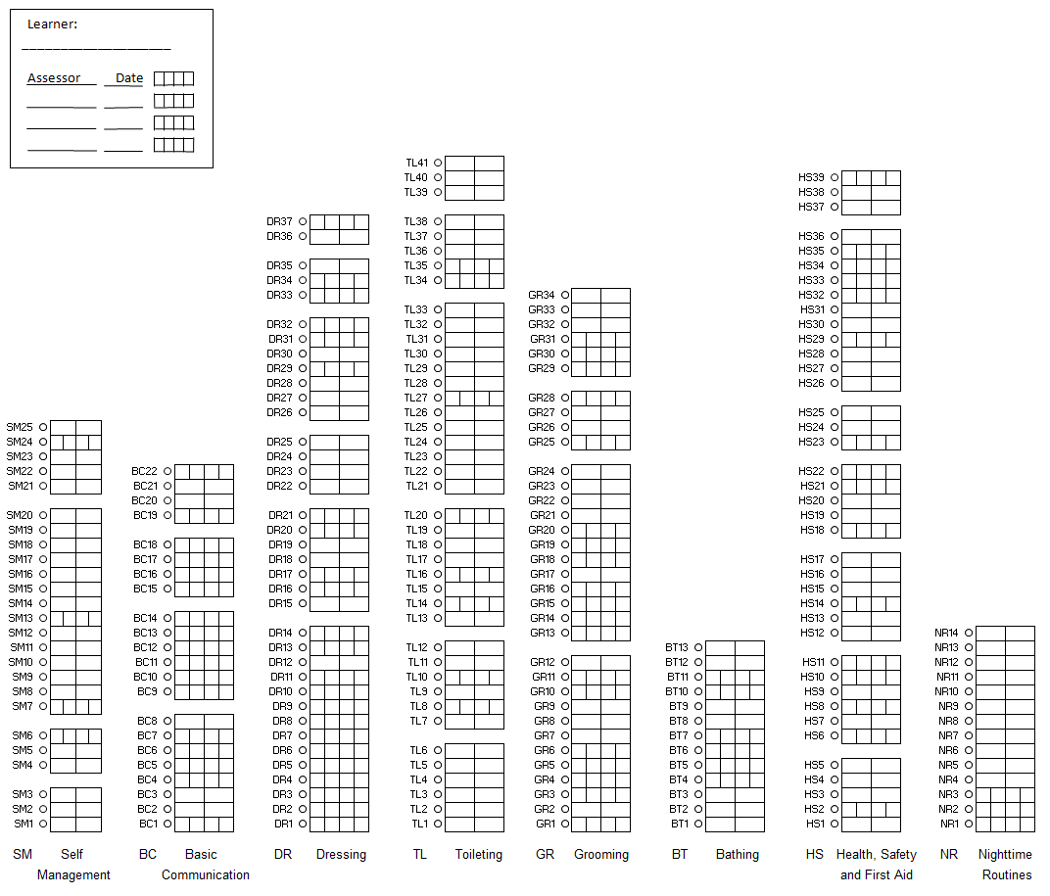

(Insert page break)

**Adaptive Behavior Assessment System, Third Edition (ABAS-3)**

**Date Administered: XX/XX/XXXX**

**Name of Interview: First Name/Last Name, Credentials**

**Name of Respondent: First Name/Last Name, relationship**

**Age: XX years, XX months**

**Age at Testing: XX years, XX months**

**Assessment Summary:**

Write a brief narrative about the results and include the following in a paragraph:

|  |  |  |  |
| --- | --- | --- | --- |
| **Skill Area** | **Raw Score** | **Scaled Score** | **Description** |
| **Communication** |  |  |  |
| **Community Use** |  |  |  |
| **Functional Academics** |  |  |  |
| **Home Living** |  |  |  |
| **Health and Safety** |  |  |  |
| **Leisure** |  |  |  |
| **Self-Care** |  |  |  |
| **Self-Direction** |  |  |  |
| **Social** |  |  |  |
| **Work** |  |  |  |

(Insert page break)

1. ***Target Behaviors***

**Behavior #1 (Insert Behavior Name)**

*Assessor will follow this behavior series for each target behavior Identified.*

1. ***Descriptive Phase***
   * **Topography of Behavior:** Operational definition of the target behavior. The definition will be observable, measurable, and objective. (Based on this technological description all individuals will be able to easily recognize and record behavior). Definition should include criteria regarding what is and is not counted as the target behavior (e.g., duration, severity, instances vs. episodes, etc.).
   * **Onset/Offset:** Statement regarding when the behavior begins and ends.
   * **Course of Behavior:** Describe whether or not the behavior occurs across (persons, places, and times of the day). List any escalation patterns and/or cycles. Describe how the behavior typically subsides.
   * **History and recent changes:** Write a brief statement regarding the history of the behavior and any recent changes to the behavior.
   * **Source:** What social significance does the behavior serve (e.g., parental concern, observation)
   * **Baseline Data:** Insert baseline data for target behavior.

(Insert graph – align left)

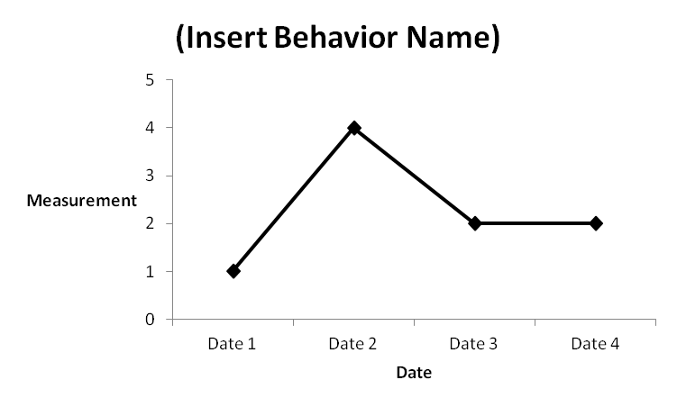

* + ***Functional Analysis Screening Tool (e.g., FAST, MAS, QABF):*** Write a brief description of the tool used. Example: *The Functional assessment screening tool is a questionnaire presented to caregivers of an individual in order to identify a hypothesized function for a given target behavior. Questions asked to caregivers are presented in a random order and designed to assess whether the behavior occurs in the presence/ absence of a variety of environmental factors.*

(Insert graph – align left)

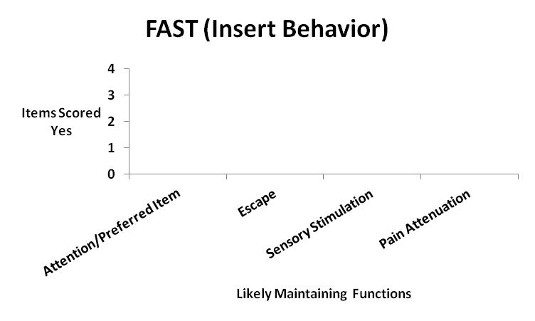

* + **Antecedent Analysis:** *within this section the assessor will identify setting of events and triggering events for the target behavior. The assessor will summarize environmental events that preceded the target behavior.*

(Insert graph – align left)

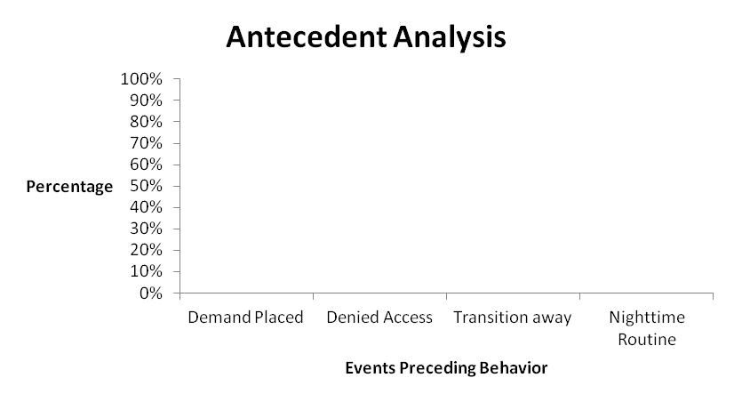

* + **Consequence Analysis:** *within this section the assessor will identify environmental events that follow/followed the target behavior.*

(Insert graph – align left)

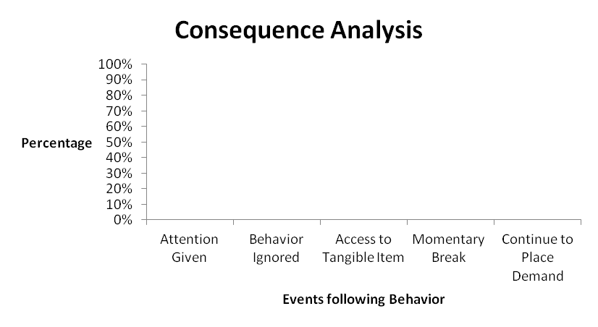

* + **Analysis of Meaning/Hypotheses:** *Based on the information gathered from (Clinical Interview, Screening Tools, Direct Observation and Structured A-B-C Data collection, Antecedent and Consequence Analysis) the hypothesized function of Member’s (insert behavior) is (insert function or multiple functions).*

1. ***Verification Phase***
   * **Functional Assessment: (*This section is optional).*** *Within this section describe the functional analysis procedures, testing conditions and the results. A graph is required for each testing condition.*
2. ***Program Goals***
3. **Behavior:**
4. **Program Name:** Title of program being targeted

**Instrumental Goal:** (By Date) Objective of the program (make sure this is measurable, objective, and specific)

**Data Collection:** How data will be collected (e.g., first trial data, rate per hour, percentage of opportunities, partial interval recording)

**Mastery Criteria:** How you will measure mastery (e.g., 3 consecutive sessions of correct responding)

**Generalization Criteria:** How you will measure if the skill is generalized (e.g., Across 3 people, 3 settings, and 3 exemplars)

**Baseline**: Include a brief statement about the Member’s current skill level including a baseline measurement that EXACTLY matches the mastery criteria of the goal.

1. **Program Name:** Title of program being targeted

**Instrumental Goal:** (By Date) Objective of the program (make sure this is measurable, objective, and specific)

**Data Collection:** How data will be collected (e.g., first trial data, rate per hour, percentage of opportunities, partial interval recording)

**Mastery Criteria:** How you will measure mastery (e.g., 3 consecutive sessions of correct responding)

**Generalization Criteria:** How you will measure if the skill is generalized (e.g., Across 3 people, 3 settings, and 3 exemplars)

**Baseline**: Include a brief statement about the Member’s current skill level including a baseline measurement that EXACTLY matches the mastery criteria of the goal.

1. **Communication:**
2. **Program Name:** Title of program being targeted

**Instrumental Goal:** (By Date) Objective of the program (make sure this is measurable, objective, and specific)

**Data Collection:** How data will be collected (e.g., first trial data, rate per hour, percentage of opportunities, partial interval recording)

**Mastery Criteria:** How you will measure mastery (e.g., 3 consecutive sessions of correct responding)

**Generalization Criteria:** How you will measure if the skill is generalized (e.g., Across 3 people, 3 settings, and 3 exemplars)

**Baseline**: Include a brief statement about the Member’s current skill level including a baseline measurement that EXACTLY matches the mastery criteria of the goal.

1. **Program Name:** Title of program being targeted

**Instrumental Goal:** (By Date) Objective of the program (make sure this is measurable, objective, and specific)

**Data Collection:** How data will be collected (e.g., first trial data, rate per hour, percentage of opportunities, partial interval recording)

**Mastery Criteria:** How you will measure mastery (e.g., 3 consecutive sessions of correct responding)

**Generalization Criteria:** How you will measure if the skill is generalized (e.g., Across 3 people, 3 settings, and 3 exemplars)

**Baseline**: Include a brief statement about the Member’s current skill level including a baseline measurement that EXACTLY matches the mastery criteria of the goal.

1. **Self-Help:**
2. **Program Name:** Title of program being targeted

**Instrumental Goal:** (By Date) Objective of the program (make sure this is measurable, objective, and specific)

**Data Collection:** How data will be collected (e.g., first trial data, rate per hour, percentage of opportunities, partial interval recording)

**Mastery Criteria:** How you will measure mastery (e.g., 3 consecutive sessions of correct responding)

**Generalization Criteria:** How you will measure if the skill is generalized (e.g., Across 3 people, 3 settings, and 3 exemplars)

**Baseline**: Include a brief statement about the Member’s current skill level including a baseline measurement that EXACTLY matches the mastery criteria of the goal.

1. **Program Name:** Title of program being targeted

**Instrumental Goal:** (By Date) Objective of the program (make sure this is measurable, objective, and specific)

**Data Collection:** How data will be collected (e.g., first trial data, rate per hour, percentage of opportunities, partial interval recording)

**Mastery Criteria:** How you will measure mastery (e.g., 3 consecutive sessions of correct responding)

**Generalization Criteria:** How you will measure if the skill is generalized (e.g., Across 3 people, 3 settings, and 3 exemplars)

**Baseline**: Include a brief statement about the Member’s current skill level including a baseline measurement that EXACTLY matches the mastery criteria of the goal.

1. **Social Skills:**
2. **Program Name:** Title of program being targeted

**Instrumental Goal:** (By Date) Objective of the program (make sure this is measurable, objective, and specific)

**Data Collection:** How data will be collected (e.g., first trial data, rate per hour, percentage of opportunities, partial interval recording)

**Mastery Criteria:** How you will measure mastery (e.g., 3 consecutive sessions of correct responding)

**Generalization Criteria:** How you will measure if the skill is generalized (e.g., Across 3 people, 3 settings, and 3 exemplars)

**Baseline**: Include a brief statement about the Member’s current skill level including a baseline measurement that EXACTLY matches the mastery criteria of the goal.

1. **Program Name:** Title of program being targeted

**Instrumental Goal:** (By Date) Objective of the program (make sure this is measurable, objective, and specific)

**Data Collection:** How data will be collected (e.g., first trial data, rate per hour, percentage of opportunities, partial interval recording)

**Mastery Criteria:** How you will measure mastery (e.g., 3 consecutive sessions of correct responding)

**Generalization Criteria:** How you will measure if the skill is generalized (e.g., Across 3 people, 3 settings, and 3 exemplars)

**Baseline**: Include a brief statement about the Member’s current skill level including a baseline measurement that EXACTLY matches the mastery criteria of the goal.

1. ***Behavior Intervention Plan***
   1. ***Ecological Strategies-*** *Within this section of the behavior intervention plan describe all ecological strategies used.* ***Strategies should be written technological*** 
      * ***(Insert Strategy)- Description of the strategy and instructions for implementation.***
      * ***(Insert Strategy)- Description of the strategy and instructions for implementation.***
   2. ***Antecedent Based Intervention Strategies-*** *Within this section of the behavior intervention plan describe all antecedent interventions used.* ***Strategies should be written technological. Examples include but not limited to:*** *Visual schedules, priming, clear expectations, first/then contingency training, structured choices, etc.…*
      * ***(Insert Strategy)- Description of the strategy and instructions for implementation.***
      * ***(Insert Strategy)- Description of the strategy and instructions for implementation.***
   3. ***Reactive/Consequence Based Intervention Strategies-*** *Within this section of the behavior intervention plan describe all consequence interventions used.* ***Strategies should be written technological. Examples include but not limited to redirection, extinction, differential reinforcement, etc.…***
      * ***(Insert Strategy)- Description of the strategy and instructions for implementation.***
   4. ***Safety Procedure-*** *Within this section please provide safety procedures used to keep the Member and other’s safe during crisis situations, extinction bursts, and behavior escalation. This can include any special instructions from the QASP’s adoptive Crisis Prevention Training Programs (e.g., Nonviolent Crisis Intervention, Safety-Care Behavioral Safety, Professional Crisis Management, or Professional Assault Crisis Training).*
2. **Teaching Intervention Strategies-** *Within this section list all teaching procedures and methodologies used to the teach skill deficits and replacement behaviors.**Include strategies on generalization, maintenance, thinning schedules of reinforcement, transition to natural mediators, and relapse prevention.*
   1. ***(Insert Teaching Approach/Strategy/Procedure)- Provide a description of the research and evidence-based teaching approach. Additionally, provide any instructions for implementation.***
3. ***Family Involvement:*** *Within this section of the report Provider will outline parent involvement and participation within the therapy session. Provider will include a statement on the expected level of participation as outlined within the Behavioral Health Treatment IEHP Policy. Provider will outline the parent training and education approach for teaching the parent goals. Providers will include a plan on how the provider will address parental involvement within therapy sessions.**Parent education goals will be listed below.* ***Parent Participation is not an education goal, it is an expectation. A Parent should have AT LEAST 2 Parent Education Goals.***
4. **Parent Education:**
5. **Parent Goal Domain:** Title of Domain being targeted

**Instrumental Goal:** Objective of the program (make sure this is measurable, objective, and specific) include data collection procedure and mastery criteria.

**Baseline**: Include a brief statement about the Member’s Parent’s current skill level including a baseline measurement that EXACTLY matches the mastery criteria of the goal.

1. **Parent Goal Domain:** Title of Domain being targeted

**Instrumental Goal:** Objective of the program (make sure this is measurable, objective, and specific) include data collection procedure and mastery criteria.

**Baseline**: Include a brief statement about the Member’s Parent’s current skill level including a baseline measurement that EXACTLY matches the mastery criteria of the goal.

1. ***Location of Service:*** *Include a description on where services will take place.* **Provider may not provide services in the school setting, day care, or other locations in which parent or caregiver is not present, unless prior authorization is given by the health plan.**
2. ***Coordination of Care:*** *Include a description on how the treatment team assigned to the Member’s case will work* collaboratively with, their school and other health care professionals involved in the care of a Member (e.g., PCP, OT, SLP, etc.).
3. ***Discharge Criteria:*** *Within this section include a description regarding the discharge criteria and transition of care. Transition of care should include Member aging out of BHT services at the age of 21. Authorizations for BHT will not extend past the Member’s 21st birthday. For Members who are within sixty (60) days of their 21st birthday, the BHT Provider must initiate the transition process to an alternative funding source (e.g., Regional Center, County Services, or Department of Rehabilitation).*
4. ***Recommendations:*** *Within this section provide a summary of the clinical recommendations for the Member. This should include the rationale for* ***MEDICALLY NECESSARY*** *behavioral health treatment. The rate of supervision provided by the QAS Professional and/or QAS Provider to the QAS Paraprofessionals will be based on a ratio of 2 hours of supervision service per every 10 hours of direct service authorized, unless the case calls for increased supervision as agreed by QAS Provider and IEHP Health Plan.* ***Providers requesting additional supervision beyond standard ratios and guidelines will need to include clinical justification on the need for enhanced supervision***

|  |  |  |
| --- | --- | --- |
| **Clinical Recommendations** | | |
| **CPT** | **Description** | **Units Requested** |
| **H2019** | **Therapeutic Behavioral Services, per 15 minutes** |  |
| **H0032** | **Mental Health Service Plan Development by Non-Physician, per 15 minutes (Mid-Tier Supervision by Non-certified/non-licensed Masters, BCaBA, BA enrolled in BCBA Program)** |  |
| **H0032-HO** | **Mental Health Service Plan Development by Non-Physician, per 15 minutes (Top-Tier Supervision by BCBA/LMFT/LCSW)** |  |
| **H0032-HP** | **Mental Health Service Plan Development by Non-Physician, per 15 minutes (Top-Tier Supervision by BCBA-D/Ph.D.)** |  |
| **S5111** | **Home Care Training, Family; per session**  **(By BCBA, BCaBA, MA staff)** |  |
| **H2014** | **Skills Training and Development, per 15 minutes**  **(By BCBA, BCaBA, MA staff)** |  |

**Report completed by:**



_____________________________________

Name Date:

Title

Agency Name

**Report reviewed and approved by: *The Health plan requires a second review by BCBA***



____________________________________

Name Date:

Title

Agency Name